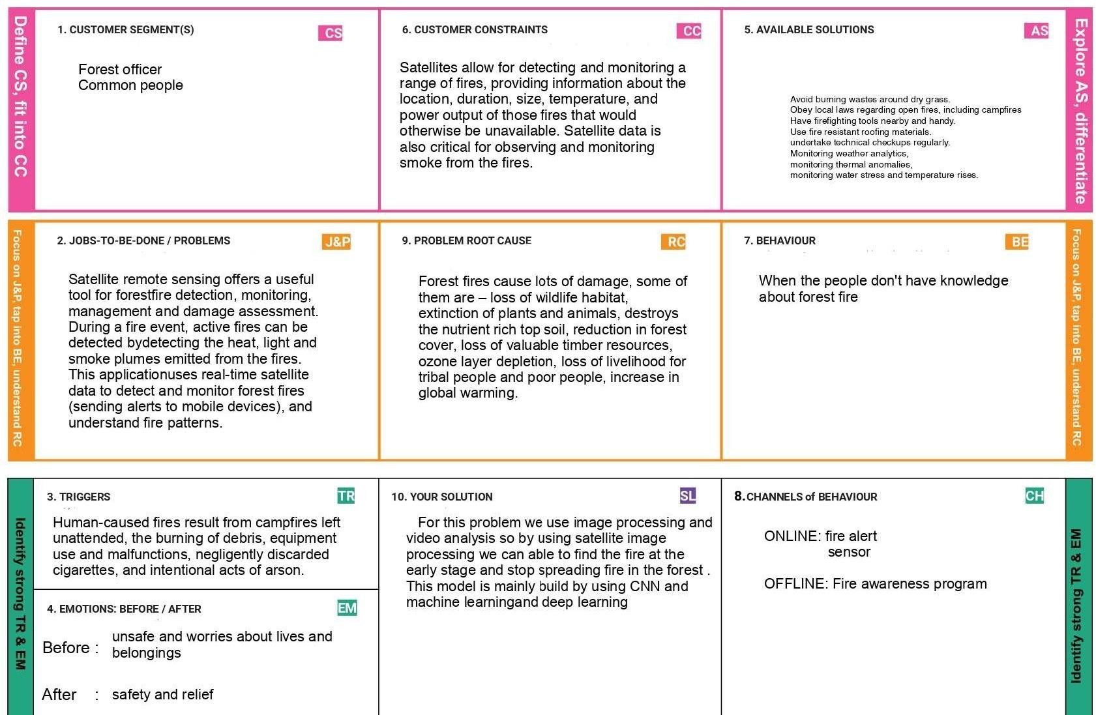**Project Title:** EMERGING METHODS FOR EARLY DETECTION FOREST FIRE SOLUTION FIT TEMPLATE

**TEAM ID:** PNT2022TMID13406

|  |  |  |  |  |
| --- | --- | --- | --- | --- |
| O | 3. TRIGGERS  Human-caused fires result from campfires left unattended, the burning of debris, equipment use and malfunctions, negligently discarded cigarettes, and  intentional acts of arson. | 10. YOUR SOLUTION  For this problem we use image processing and video analysis so by using satellite image processing we can able to find the fire at the early stage and stop spreading fire in the forest | 8. CHANNELS of BEHAVIOUR  ONLINE: fire alert sensor  OFFLINE: Fire awareness program |  |

|  |  |  |  |  |  |
| --- | --- | --- | --- | --- | --- |
|  |  | 4. EMOTIONS: BEFORE / AFTER  unsafe and worries about lives and  Before .  belongings  After safety and relief | . This model is mainly build by using CNN and machine learningand deep learning |  |  |
|  | | 2. JOBS-TO-BE-DONE / PROBLEMS  Satellite remote sensing offers a useful tool for forestfire detection, monitoring, management and damage assessment. During a fire event, active fires can be detected bydetecting the heat, light and smoke plumes emitted from the fires. This applicationuses real-time satellite data to detect and monitor forest fires (sending alerts to mobile devices), and  understand fire patterns. | 9. PROBLEM ROOT CAUSE  Forest fires cause lots of damage, some of them are — loss of wildlife habitat, extinction of plants and animals, destroys the nutrient rich top soil, reduction in forest cover, loss of valuable timber resources, ozone layer depletion, loss of livelihood for tribal people and poor people, increase in global warming. | 7. BEHAVIOUR  When the people don't have knowledge about forest fire |  |

Common people range of fires, providing information about the location, duration, size, temperature, and Avoid buming wastes around dry grass.

power output of those fires that would Obey Have firefighting local law'S regarding tools nearby open and fires, handy.including campfires otherwise be unavailable. Satellite data is use fire resistant roofing materials.

also critical for observing and monitoring undertake Monitoring technical weather analytics,checkups

smoke from the fires. monitoring thermal anomalies, monitoring water

stress and temperature rises.